[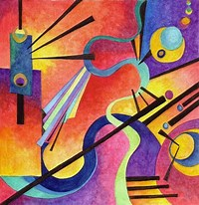](https://www.bing.com/images/search?q=kandinsky+images+of+work&id=C719091C19A040910340D7AC2C5234AAFFDBC0FA&FORM=IQFRBA)[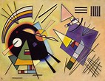](https://www.bing.com/images/search?q=kandinsky+images+of+work&id=032FBD953271A15FA9FD7A3F52EE627389BA1C2A&FORM=IQFRBA)[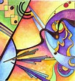](https://www.bing.com/images/search?q=kandinsky+images+of+work&id=2D4D80134D1D593688AEBDFD3C6F98AC58E0F575&FORM=IQFRBA)[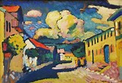](https://www.bing.com/images/search?q=kandinsky+images+of+work&id=AE1B56D0AA1C91CAF8AEB856E43F3436731480E3&FORM=IQFRBA)[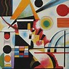](https://www.bing.com/images/search?q=kandinsky+images+of+work&id=11FAB1EAF2434C8F8C36969A5B8393CB4FF0C00A&FORM=IQFRBA)[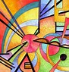](https://www.bing.com/images/search?q=kandinsky+images+of+work&id=5C820893F61BEDD000366EC3413EF2A56AEAE18A&FORM=IQFRBA)[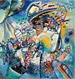](https://www.bing.com/images/search?q=kandinsky+images+of+work&id=85D9543D7DE9CB2247543921034163C1F4A3B973&FORM=IQFRBA)[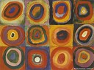](https://www.bing.com/images/search?q=kandinsky+images+of+work&id=E214BA4AFF32F6A1F254D20CBDA4D2D49AC26283&FORM=IQFRBA)[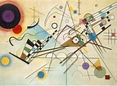](https://www.bing.com/images/search?q=kandinsky+images+of+work&id=EB67473EC8584C971A141A68613D9B267A0C77F5&FORM=IQFRBA)[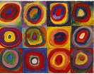](https://www.bing.com/images/search?q=kandinsky+images+of+work&id=7813AA34CDF15C5D69FEFAFC320B768D2C5E3E89&FORM=IQFRBA)[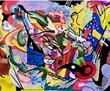](https://www.bing.com/images/search?q=kandinsky+images+of+work&id=CFC7F61E1875CAB41EE53A0B5FBCDE6F3D373110&FORM=IQFRBA)[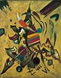](https://www.bing.com/images/search?q=kandinsky+images+of+work&id=300B487A98485BDEC4D593F19218E639F75A7CD8&FORM=IQFRBA)[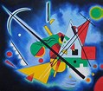](https://www.bing.com/images/search?q=kandinsky+images+of+work&id=F3013F8C412965F3644E8B667B94F0E22D3E43D4&FORM=IQFRBA)